Cuyahoga Falls Little League North
Golf Scramble Fund Raiser

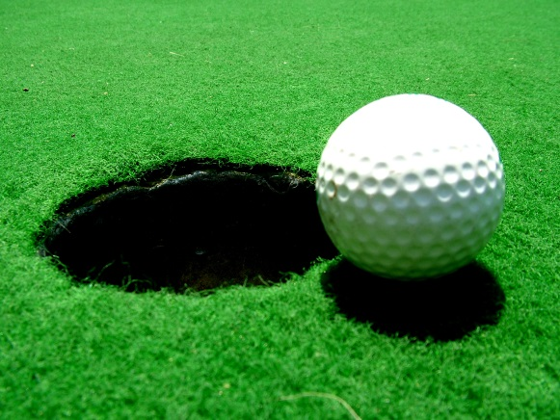
When: Saturday, August 4th
1:30pm Shotgun Start
Where: Brookledge Golf Club
1621 Bailey Road
Cuyahoga Falls, OH
What: 4 Person Scramble
Cost: $80/Person $320/Team
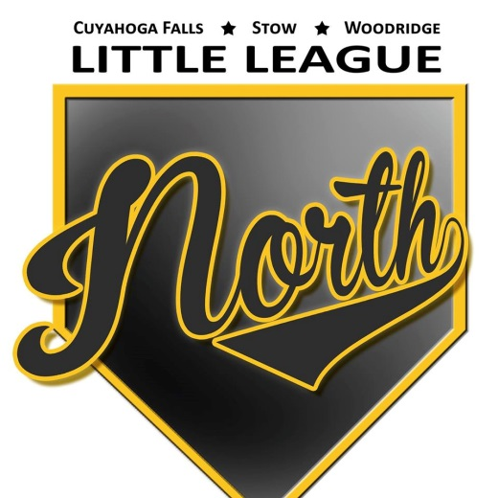
Includes: Greens Fee
Unlimited Range Balls
Lunch & Dinner
Prizes
Lunch: Hot dogs & chips will be provided starting at 12:30pm
Dinner: Catered dinner will take place after golf

------------------------------------------------------------------------------------------------------------------
Team Sign Up ($320):
______________________________
______________________________
______________________________
______________________________
Sponsors
-Hole $100,
-Practice Green/Driving Range/Golf Balls + Tees $200,
-Lunch $300,
-Dinner $500
*Sponsor + Team entry gets $20 discount
___________________________

