Cuyahoga Falls Little League North
PO Box 3444, Cuyahoga Falls, OH 44223
PRSRT STD
US Postage
PAID
Cuyahoga Falls OH
Permit No. 39


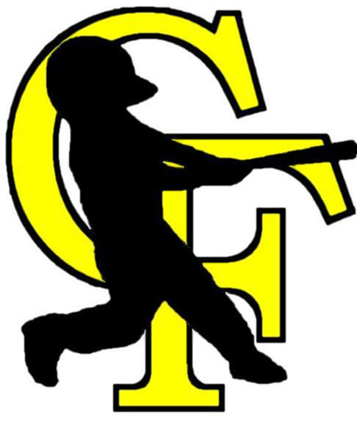 C.F.L.L.N. News
Volume 10, Issue 3 A Newsletter for Parents, Players and Supporters of Cuyahoga Falls Little League North Baseball
April 2012 HOME OF THE 2012 LITTLE LEAGUE 9/10 YEAR OLD STATE CHAMPIONSHIPS

Welcome to Cuyahoga Falls Little League!
The Season is kicked off
Time for the games to begin!

The season has started for the Majors and AAA games. We have already had some exciting games and look forward to the continued support of all the coaches, parents and our children in keeping CFLLN a first class organization.

Check out the new webpage at www.CFLLN.com with all the details for the season including updates

We are available for your comments and concerns in helping us continue the tradition. Never hesitate to contact Mike Pollard at 330-701-9561 and/or any of the board members listed below.

INSIDE:

City Championship

2012 Little League State Championship at CFLLN Complex
To the Parents or Guardians of:

Mailing Address Label

Page 2 CFLLNews April 2012

Fundraising Efforts

Cuyahoga Falls Little League North is a Not-for-Profit Organization that receives no local, state or federal funding for the 9+ acre complex on Wyoga Lake Road.
Player registration fees and fundraising efforts, as well as corporate and private donations, provide ALL financial support for the league’s 30 teams and over 300 players. As with many non-profit organizations, fundraising is the major source of revenue. In our case, every dollar that is raised goes directly to our league to support uniforms, building and grounds maintenance, equipment, concession stand and tournaments.
CFLLN is run solely by volunteers, including the board. We are appreciative of the countless volunteer hours spent working on the fields, in the concession stand and behind the scenes.
This year we have updated the parking lot with new pavement and have upgraded all the dug outs. Without your continued support we would not be able to address these types of much need improvements.
Mike Teodecki is coordinating the fundraising efforts this season. We encourage you to attend the events this year. Have fun and raise money for your CFLLN players at the same time!

2012 Fundraising Efforts

Night at the Races – Friday, May 18, 2012
This casual, fun dinner and “gaming” event is for parents and league supporters. First timers are strongly encouraged to attend! It’s a great way to get to know your coaches and other parents. Seasoned guests- we appreciate your support and look forward to seeing you there!

Banners – Fill the Fences - Businesses have stepped up and you will see the banners displayed on outfield fences and/or backstops throughout the baseball complex. Thank you to everyone for your continued support for Cuyahoga Falls Little League North.

2012 CFLLN Board Members

President Mike Pollard 330.701.9561
Executive VP Chris Martin 330.920.1991
Treasurer Ben Asher 330.289.2625
Major League VP Marc Haas 330.940.2140
Minors VP (AAA) Tom Sullivan 216.233.9006
Minors VP (AA) Mark Kahook 330.608.3333
Instructional VP Wes Perry 330.688.8700
Players Rep. John Patterson 330.920.9733
Facilities Dave Albright 330.928.8947
Gary DeRemer 330.929.0688
Equipment Matt Tartaglia 330.928.9826
Web Page Mark Kahook 330.608.3333
Pat Larson 330.329.3842
Fundraising Mike Teodecki 330.945.6902
Safety Officer Chris Martin 330.920.1991
Concessions Dawn Albright 330.928.8947
Dave Albright 330.928.8947
Secretary John Patterson 330.920.9733

UMPIRES

NEEDED
Anyone interested in umpiring or becoming an umpire for the 2002 Little League season, please contact David Wood at 330- 929-8961. Training and uniforms will be provided. Both home base and base umpires needed.

FRIDAY NIGHT LIGHTS!

Beginning April 27 and Every Friday during the 2012 season, fans can cheer and players can enjoy the thrill of playing under the stadium lights. One Major League game will be scheduled each Friday night.

Mandatory Manager’s Applicant Meeting
If you are interested in being a team manager in Majors, AAA or AA you must attend the Managers’ Applicant Meeting to be held Thursday, February 6 at Silver Lake Country Club. The meeting will begin at 7:00 pm and last approximately 90 minutes.
If you are interested in being a manager or coach at any level, please submit the enclosed Volunteer Application by the January 25th deadline.

LITTLE LEAGUE STATE CHAMPIONSHIPS TO BE PLAYED AT THE CFLLN COMPLEX
CFLLN Little League Baseball is chartered by Little League Baseball of America, Inc. We are a non-profit organization whose goal is to instruct, develop, and provide the children of the community with an opportunity to learn and play competitive baseball. Over the years CFLLN has been and continues to be a very successful organization posting several districts champions. This year we are proud to announce that we have been awarded the State of Ohio Little League State Championship for the 9/10 year old level. The tournament will be held July 29-August 4. This is a great accomplishment for this fine community and organization. We look forward to your child taking part in the Little League experience.

UMPIRE

CFLLN is a volunteer organization and we would like to remind everyone attending the games to be courteous and sportsman-like during the games. Without the fine men and women that dedicate their time to the league, we would be lost. So please help by respecting the ump, so all can enjoy the game.
CFLLN 2012 Calendar of Events

April16 Opening Day for Majors

April19 Opening Day for AAA

April 21 Opening Day for AA and Single A

April 22 Opening Day for AA and Single A

April 22 Dugout Painting (Weather Permitting)

Fri. May 18 Night at the Races Fundraiser at 6:00 pm @ Stow Youth Baseball (SYB) Hall
4157 Hudson Drive, Stow

Week of June 18 City Championship for the AAA and Majors vs. CFLL South

July/ August, 2012 9/10 Little League State Championship

2012 at a Glance
- We have continued to improve the best Little League complex in Ohio with a new paved roadway in the parking lot.

- The facilities have had renovations win several areas and we are in the process of painting the dugouts. We will be out in the complex Sunday April 22nd from 11 am till we are done painting the dugouts (weather permitting) as well as finishing up some odds and ends. To all your help would be welcome , please bring paint brushes and help us finish up the field

- CITY CHAMPIONSHIP
The winning teams of the Majors and AAA will play in the City Championship versus the winners of Cuyahoga Falls Little League South

CFLLN Game Schedule

We are excited to offer inter league play with Cuyahoga Falls South and Tallmadge this season. Not only are we playing games with the Majors and AAA but we are also doing inter league with Single and Tball with Cuyahoga Falls South. As a reminder:
  - Majors play MON-WED-FRI
  - AAA play TUE-THU-SAT
  - AA and A play MON-WED-FRI-SAT
  - Tball play TUE -THU

Page 3 CFLLNews April 2012
For all the CFLLN news, updates, rain out information and more, visit our new website often. You will like the changes coming! www.cflln.com

